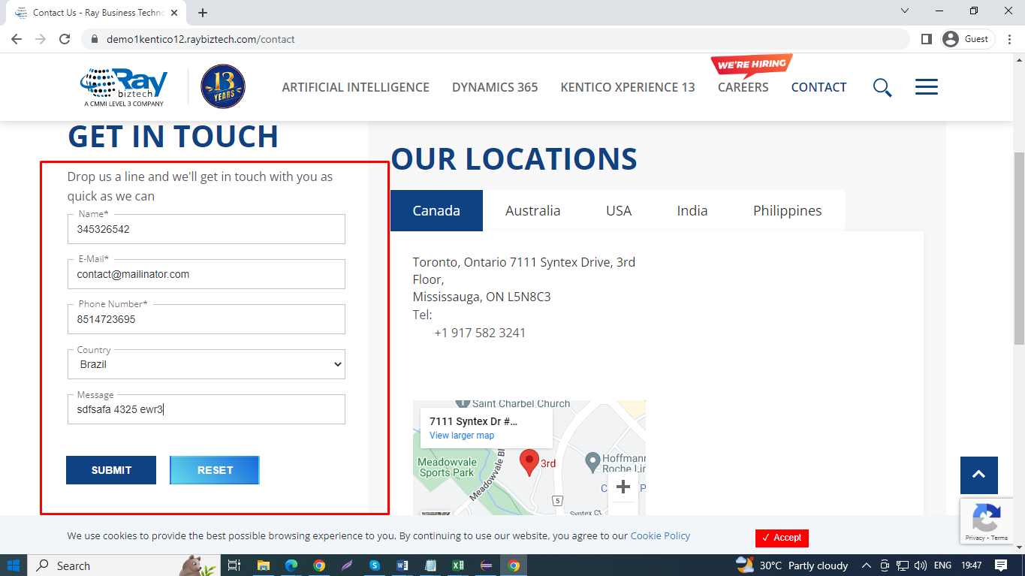

Please refer above screenshot for reference.

Contacts Form:

Actual Result:

1. Not getting validations for message field.
2. Not getting validation message If I'm entering only numbers or special characters in Name field.

Expected Result:

1. Should display validation message if entered input doesn't match with requirement.